# Setup Creator

Making a setup is easy with setup creator. First set all folders where the functions are stored to path, this can be done by the set path button:

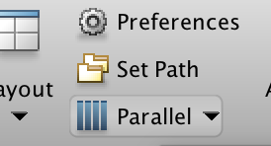

Run this MATLAB function: **SC = setupCreator();**

A GUI should appear, select the parameter files that can be found here:

Once you have imported all of the files you should be able to name and save the setup.

# Setup Compare

To compare setups run this MATLAB function**: SC = setupCompare();**

A GUI should appear with a button to import a setup. When clicking this button another GUI should appear where you can select a setup to import. After importing a setup the program will run the simulations.

Once the simulation is completed it should appear on the plots, like below:

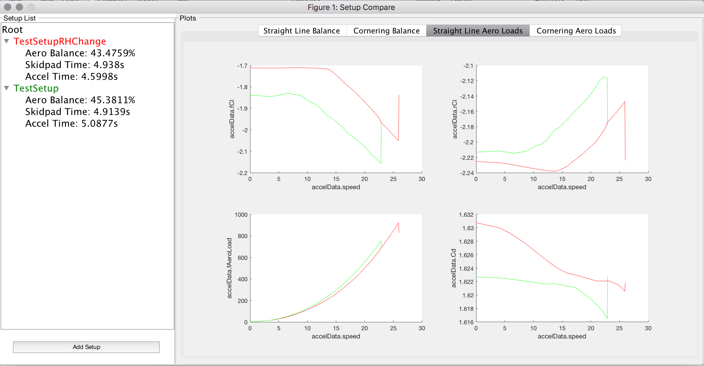

Multiple setups can be compared, and plot information can be changed by adjusting the tabPlots.mat file here: *Setup Compare/ tabPlots.mat*

The format of the .MAT is as follows:

**plotsTab(count).X(a)** – controls the X axis

**plotsTab(count).Y(a)** – controls the Y axis

**plotsTab(count).name** – controls the name of the tab

**count** – controls the tab displayed on

**a** – controls which plot the information is displayed on